# **Usability Testing Report**

**Executive Summary**

A usability testing regarding on a high fidelity prototype of “Fitness Pro” fitness tracking mobile application was carried out on 15 August 2018, starting from 1:00 pm until 2:00 pm. The main purpose of usability testing is to elicit information on how real users interact with the product and results gathered are used to enhance and consolidate the core functionality of product. Moreover, the usability testing is executed to improve the design and overall performance of the product by doing user satisfaction survey. We glad that we had utilized this short period of time while clarifying the importance of usability testing. As consequences, it provides us a large amount of qualitative data on user reactions and feedback about the product.

There were total six usability testers (3 Novices & 3 Experts) participated in the test. In each session, usability tester was requested to sign the consent form. This was to ensure that the usability tester is agree with procedure of devoting oneself to complete the task listed in the test scenario. Then, he was asked to answer a few questions to indicate whether he was an expert or a novice user before started to complete task given in the test scenario within 10 minutes. Chin Kai Xiang played the role of facilitator, who provided appropriate guidelines and hints usability tester. He obliged to remind the testers that they were using a mobile application although it was displayed on the computer screen. Au Yee Siong played the role of time- taker. He recorded time taken of usability tester to complete each usability function. Chuah Shang Chen and Low Zi Jian played the role of observer & notetaker. They recorded the way of user interacted with the product (pathway) in the notetaker guidebook and video capturing. These were the criteria they focused in:

* Difficulties in finding the object of interaction
* Error made by user (observe if the users navigating the previous links for some times)
* Optionally, may ask the users to do think-out-loud while performing the task in order to know the tester's expectations of, and reactions to, the software he or she tests.
* user makes interesting comments or suggestions

Test scenarios that participants completed were:

1. Setting goal
2. Tracking daily goals and keeping a log of daily activities
3. Showing notification/ reminder for motivation
4. Visualizing the progress or showing important statistics
5. Inviting friends to the group for community and accountability to keep up the habit
6. Share result/ experience of challenges to the community group for encouragement

In conclusion, 65% of 6 usability testers is satisfy with “”Fitness Pro” fitness tracker mobile application. From the statistical report, we found out that major reason of having difficulty / fail to complete the test scenarios given is confusing page layout. According to our observation, we found out usability testers confused with page layout at setting goals.

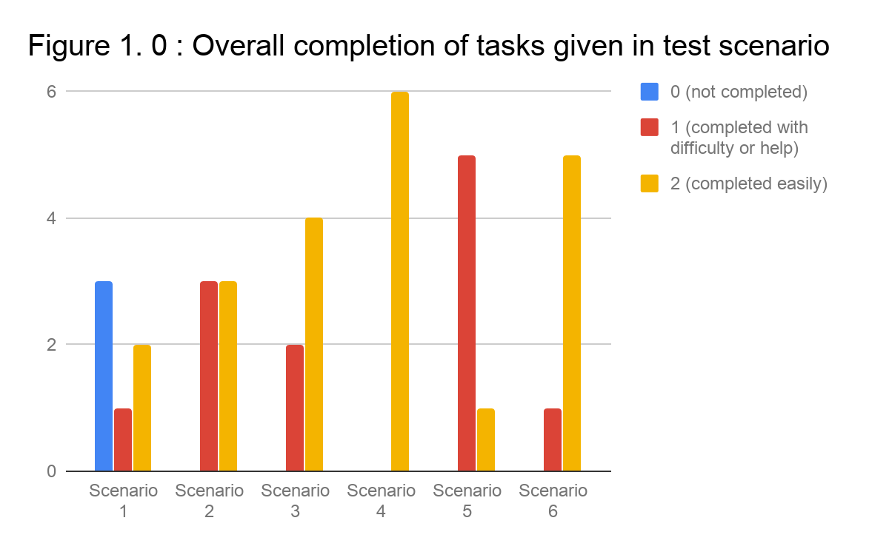

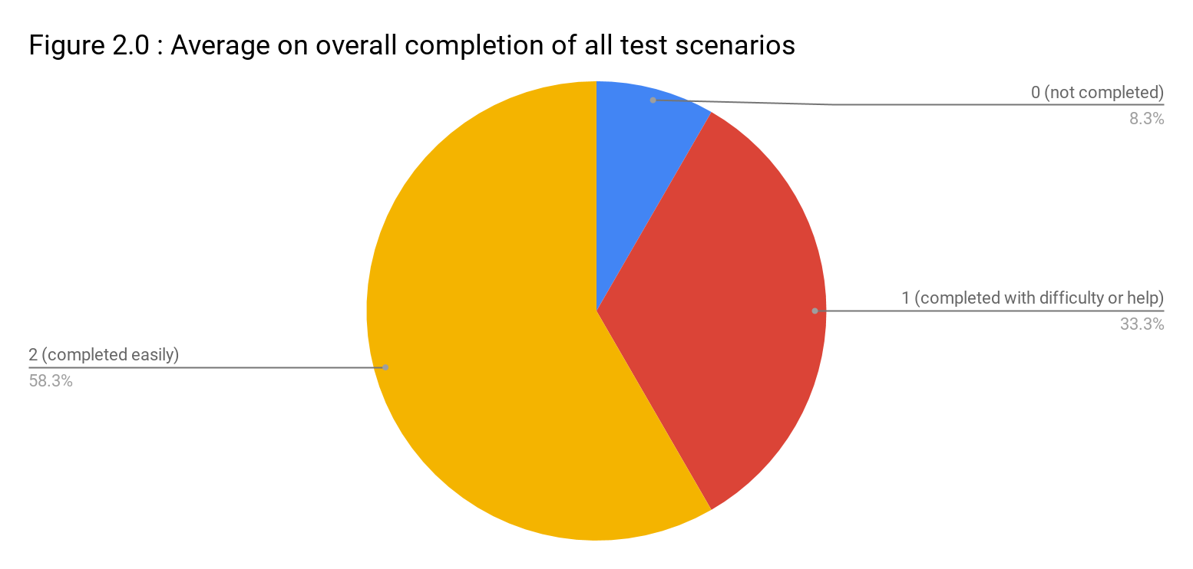

## 

## 

## 

## Points scored

## 

## 

## 

## 

## 

## Points scored

## 

## 

## 

## 

## 

## 

## 

## **User Profile**

**Participant # 1:**

Chin Kai Wen, 19, male is considered a novice because the number of applications he is only 5. Besides, he said that he needs helps from guidelines when using new mobile applications. Furthermore, he claimed that he took around 1 day to familiarize with a new mobile application. He also didn’t use any fitness application before and we found from the usability testing section that he needs some helps from facilitator to complete certain tasks.

**Participant # 2:**

Kok Zi Yi, 19, male is considered a novice because he seldom uses his mobile phone as he always focuses on his study. Although his mobile phone is installed with more than 5 applications but he seldom use them and he needs helps from guidelines when he uses new mobile application. Besides, he claimed that he needs around 1 week to familiarize with a new mobile application. We also found that he needs our help to complete some tasks during usability testing section.

**Participant # 3:**

Chong Ting Hong, 21, male is considered an expert who is familiar with a mobile applications. He is using a variety of mobile applications now such as mobile games, fitness application, and communication application and so on. Since he is an expert to mobile applications, he doesn’t needs any guides or helps when using new mobile applications instead he loves to explore himself with the new applications. He claimed that he can learn and familiarize with a new application around 1 hour.

**Participant # 4:**

Chong Wintson, 19, male is considered an expert as he is using a variety of applications such as health monitoring application, mobile games and so on. He also claimed that he uses Facebook very oftenly. More oftenly, he can familiarise and learn with a new mobile applications around 1 hour without any helps from the applications but he admitted that there is still a small probability that he will need the guides or helps in some occasions.

**Participant # 5:**

Tey Chee Leong, 19, male is considered an expert to mobile applications as he claimed that he plays mobile games oftenly and he also uses other types of applications such as money saving application, online newsfeed and so on. He claimed that he can familiarise with a new mobile application in around 1 hour and without any helps or guides from the application as he loves to explore the application by himself rather than following the boring guidelines.

**Participant # 6:**

Kee Zheng Yi, 20, male is considered a novice to mobile applications. Although he is using more than 5 mobile applications but he is not always using them. He just opens and uses the applications when he is boring and really don’t have anything to do. Moreover, he claimed that he needs helps or guides from the applications when he is using new mobile applications and it takes around 1 day for him to get familiarise with the new applications.

## 

## 

## 

## 

## **Methodology**

### **Who we tested**

Six participants, having the following characteristics, evaluated Fitness Pro Application.

|  |  |  |  |  |  |  |  |  |  |  |  |  |  |  |  |  |  |  |  |  |  |  |  |  |  |  |
| --- | --- | --- | --- | --- | --- | --- | --- | --- | --- | --- | --- | --- | --- | --- | --- | --- | --- | --- | --- | --- | --- | --- | --- | --- | --- | --- |
| **Audience Type**   |  |  | | --- | --- | | novice | / | | knowledge intermittent |  | | expert | / | | **TOTAL (participants)** | **6** | | **Time Taken to Familiarize with new mobile application**   |  |  | | --- | --- | | 1 hour | / | | 1 day | / | | 1 week | / | | **TOTAL (participants)** | **6** | | **Number of application/ system used**   |  |  | | --- | --- | | 0 |  | | 1 - 5 | / | | > 5 | / | | **TOTAL (participants)** | **6** | |
| **Age**   |  |  | | --- | --- | | <=19 | / | | 20 | / | | 21 | / | | >21 |  | | **TOTAL (participants)** | **6** | | **Gender**   |  |  | | --- | --- | | Women |  | | Men | / | | **TOTAL (participants)** | **6** | |  |

### 

### 

### **What participants did**

On 15 August 2018 (Wednesday), the invited participants arrived at the usability testing lab at KB606 around 1.00pm. There was a total of 6 participants who carried out the usability testing on our mobile application which is called “Fitness Pro” and the whole usability section took around 1 hour to finish. Besides, each participant was asked to carry out all of the six major functions of our mobile application which were setting goal, tracking daily goals and keeping a log of daily activities, showing notification/ reminder for motivation, visualizing the progress or showing important statistics, inviting friends to the group for community and accountability to keep up the habit, share result/ experience of challenges to the community group for encouragement. During the usability testing section, they were assisted by the facilitators. After the usability testing section finished, they were asked to fill in the satisfaction form and consent form.

### **What data we collected**

From this usability testing section, we collected the time taken by the participants to complete the tasks. Furthermore, we recorded the ease of completion of tasks by the participants and together with any errors made by them during the tasks. Moreover, we also recorded the pathways taken by the participants to complete their tasks which were useful for us to compare with the expected pathways so that we can carry out more detailed analysis about why participants made errors. After the usability testing section, we collected the participants’ satisfaction ratings through satisfaction form and these data will be used to calculate overall satisfaction level. Using the satisfaction form, we also collected some comments from participants about our mobile application. Besides, we also asked for the participants’ suggestions on possible improvements for our mobile application after every participant finished.

**Scenario 1 – Setting goal**

|  |  |
| --- | --- |
| Number of participants | 6 |
| Percent successful | 50% |

|  |  |  |
| --- | --- | --- |
| Participant (N1,I1,E1…) | Time to complete task (sec) | Number of error(s).Specify the errors- where, when, how. |
| **N1** | **27s** | **Number of error(s):** 1 **Error(s) made:** Not sure whether to press “Add” or “Confirm” in order to add goals at the goal setting page. (Confusing Page Layout) |
| **N2** | **20s** | **Number of error(s):** 1 **Error(s) made:** Skip the addition of activities into the list of activities to be added and straight press the “Confirm” button. (Confusing Page Layout) |
| **E1** | **34s** | **Number of error(s):** 1 **Error(s) Made:** Skip the selection of new activity and its difficulty. Participant directly pressed add and confirm button. (Confusing Page Layout) |
| **E2** | **22s** | **Number of error(s):** 1 **Error(s) made:** Skip the addition of activities into the list of activities to be added and straight press the “Confirm” button. (Confusing Page Layout) |
| **E3** | **18s** | **Number of error(s):** 0 **Error(s) made:** - |
| **N3** | **21s** | **Number of error(s):** 0 **Error(s) made:** - |

|  |  |
| --- | --- |
| Findings | Recommendations |
| E3 and N3 participants completed  the task with ease (score of “2”) by  setting a new goal successfully  (Activity: Pushups & Difficulty:  Normal).  N1 participant needed prompting or had significant difficult completing the task (score of “1”) because he/she wasthinking about whether to press the “Add” or “Confirm” button when he/she wants to add a new goal.  N1 and E2 participants did not complete the task (score of “0”) because they straight skipped the addition of activities into the list of activities to be added and straight pressed the “Confirm” button as they thought that they only need to press the “Confirm” button in order to add a new goal.  E1 participant did not complete the task (score of “0”) because he/she straight pressed the “Confirm” button without selecting the activity and difficulty.    E3 and N3 participants set a new  goal successfully via:  **Press “New Goal”**  ↓  **Select activity (Pushups)**  ↓  **Select difficulty (Normal)**  ↓  **Press “Add”**  ↓  **Press “Confirm”** | * Remove the step which is the addition of the activities into the list to be added before confirming the activities. This is because the current goal setting page layout is quite confusing as two of the users has skipped this step. They think that to add a new goal they only need to press the “Confirm” button and therefore, this step is unnecessary and has caused confusion. * Separate the goal setting steps into multiple stages/pages which are navigable to give users more control and to ensure that users can complete the goal setting stages well. * Put a status bar on the top section of the each page related to goal setting which to indicate the current stage in the goal function and to give user a sense of achievement after each stage. |

### 

### **Scenario 2 – Tracking daily goals and keeping a log of daily activities**

|  |  |
| --- | --- |
| Number of participants | 6 |
| Percent successful | 70 - 80 % |

|  |  |  |
| --- | --- | --- |
| Participant (N1,I1,E1…) | Time to complete task (sec) | Number of error(s).Specify the errors- where, when, how. |
| **N1** | **36s** | **Number of error(s):** 1    **Error(s) made:** Not sure where the activity to be completed (15 Push Ups) is located in which tab. (Confusing Terminology) |
| **N2** | **18s** | **Number of error(s):** 0  **Error(s) made:** - |
| **E1** | **2 min 8s** | **Number of error(s):** 2  **Error(s) made:**  Mixed up the definition behind progress bar and activity in the navigation menu.(wrong pathway)    Thought that completed tab haven’t been selected. He didn’t understand the difference of completed and scheduled list and its importance in tracking daily goals. (navigation issue) |
| **E2** | **24s** | **Number of error(s):** 0  **Error(s) made:** - |
| **E3** | **30s** | **Number of error(s):** 0  **Error(s) made:** - |
| **N3** | **1 min 14s** | **Number of error(s):** 1  **Error(s) made:**  Mixed up the definition behind progress bar and activity in the navigation menu.(wrong pathway) |

|  |  |
| --- | --- |
| Findings | Recommendations |
| N1 participant was not sure about where should the 15 push up located. He took a while to get used to bigger picture of the whole usability function (score of “1”)  E1 and N3 participants finding themselves difficult to access to the right page where the test scenario supposed to be carried out. They misunderstood the words in the navigation menu, or probably the definition of the icons used. (Score of “1”).  Besides, we observed E1 participant made a minor mistake as he thought that he should press the “completed” tab first hand before the log of completed activities shown out.  N2 , E2 , E3 participants learn to track daily goals and keeping themselves updating with log of daily activities with ease (score of “2”) via:  **Expand top left menu**  ↓  **Select “activity” option**  ↓  **Switch to “Scheduled” tab**  ↓  **Select “15 Push Ups” activity**  ↓  **Press start icon**  ↓  **Press stop icon** | **Navigation Menu**   * We should change the “activities” to “daily activities” and “progress bar” to “self-progress”. There might some amendment on the icon for both of these activities. * On the other hand, we might need to specific which page of the test scenario or usability function will be used in navigation menu.   **Log of daily activities**   * Completed Activities might need to be highlighted by listing out variety of activities instead of one.Eg : “15 km Running ” * Significant difference between incomplete and completed activity must be shown by changing “scheduled” tab to “Ongoing” tab.   **Track a daily activity**   * To execute a daily activity, the start icon should be replaced with “start” word and stop icon should be replaced with “stop” word. |

### 

### **Scenario 3 – Showing notification/ reminder for motivation**

|  |  |
| --- | --- |
| Number of participants | 6 |
| Percent successful | 100% |

|  |  |  |
| --- | --- | --- |
| Participant (N1,I1,E1…) | Time to complete task (sec) | Number of error(s).Specify the errors- where, when, how. |
| **N1** | **56s** | **Number of error(s):** 1**Error(s) made:** Can’t see the notification setting clearly (Same background and notification enabling/disabling button color) |
| **N2** | **1min** | **Number of error(s):** 1**Error(s) made:** Can’t see the notification setting clearly (Same background and notification enabling/disabling button color) |
| **E1** | **26s** | **Number of error(s):** 0**Error(s) Made:** - |
| **E2** | **32s** | **Number of error(s):** 0**Error(s) made:** - |
| **E3** | **30s** | **Number of error(s):** 0**Error(s) made:** - |
| **N3** | **28s** | **Number of error(s):** 0**Error(s) made:** - |

|  |  |
| --- | --- |
| Findings | Recommendations |
| E1, E2, E3 and N3 participants completed the task with ease (score of “2”) by finding the notification sent by system, log into the system and turn off the notification successfully.  N1 and N2 participants needed prompting or had significant difficult completing the task (score of “1”) because they were finding for the notification enabling/disabling button for a long time before they are able to turn off the notification in the menu. This is because that the notification enabling/disabling button in the bottom of the menu have a similar color with the background causing it difficult for the users to find it.    E1, E2, E3 and N3 participants found the notification sent by system, log into the system and turn off the notification successfully via:  **Swipe down the notification panel from top ↓ Clear the notification ↓ Expand top left menu ↓ Toggle On/ Off notification bell at below left corner** | * Change the color of the notification enabling/disabling button so that it is contrasting with the background color and easier for the users to see it. |

### 

### 

### 

### 

### 

### 

### 

### 

### 

### 

### 

### **Scenario 4 – Visualizing the progress or showing important statistics**

|  |  |
| --- | --- |
| Number of participants | 6 |
| Percent successful | 100% |

|  |  |  |
| --- | --- | --- |
| Participant (N1,I1,E1…) | Time to complete task (sec) | Number of error(s).Specify the errors- where, when, how. |
|  |  |
| **N1** | **17s** | **Number of error(s):** 0  **Error(s) made:** - |
| **N2** | **15s** | **Number of error(s):** 0  **Error(s) made:** - |
| **E1** | **31s** | **Number of error(s):** 0  **Error(s) made:** - |
| **E2** | **20s** | **Number of error(s):** 0  **Error(s) made:** - |
| **E3** | **17s** | **Number of error(s):** 0  **Error(s) made:** - |
| **N3** | **45s** | **Number of error(s):** 0  **Error(s) made:** - |

|  |  |
| --- | --- |
| Findings | Recommendations |
| All participants successfully and easily visualize the progress or showing important statistics of “Fitness Pro” (score of “2”) via:  **Expand top left menu**  ↓  **Select “Progress Bar” option**  ↓  **Swipe to the right to navigate to statistics page**  ↓  **View monthly statistics** | **Overall**   * The design is doing great and the information has been delivered clearly to the user. We may need to increase the tasks given in this scenario to let the user to have more chance to interact with this usability function.   **2nd Page**   * We may need to explain the working behind and the main purpose of statistics generated by “Fitness Pro” system |

### **Scenario 5 – Inviting friends to the group for community and accountability to keep up the habit**

|  |  |
| --- | --- |
| Number of participants | 6 |
| Percent successful | 100% |

|  |  |  |
| --- | --- | --- |
| Participant (N1,I1,E1…) | Time to complete task (sec) | Number of errorSpecify the errors- where, when, how. |
| **N1** | **1 min 30s** | **Number of error(s) :** 1 **Error(s) made :** Not sure how to add friend as the user thinks that he should add new friend in “Friends” tab. |
| **N2** | **1 min 22s** | **Number of error(s) :** 1**Error(s) made :** Not sure how to add friend as the user thinks that he should add new friend in “Friends” tab. |
| **N3** | **1 min 30s** | **Number of error(s) :** 2**Error(s) made :** - Participant misunderstood the usage of the up arrow in profile page. He kept pressing it, expecting that it will close the profile page. He totally forgotten that “Fitness Pro” is a mobile application (Confusing page layout)  **-** Participants didn’t know the usability function consists the usage of 2 different pages. (navigation issues) |
| **E1** | **1 min 25s** | **Number of error(s) :** 1**Error(s) made :** Navigate to the “Invites” page to invite friends which is not correct as this page is used to accept any friends’ invitations. (Terminology) |
| **E2** | **1 min 2s** | **Number of error(s) :** 1**Error(s) made :** Navigate to the “Invites” page to invite friends which is not correct as this page is used to accept any friends’ invitations. (Unclear Terminology) |
| **E3** | **1 min 21s** | **Number of error(s):** 0 **Error(s) made:** - |

|  |  |
| --- | --- |
| Findings | Recommendations |
| N1 and N2 participants needed prompting or had significant difficult completing the task (score of “1”) by finding the way to add friend in friend page.  N3 participant needed prompting or had significant difficult completing the task (score of “1”) by finding the suitable way to close the Michael’s profile.  E1 and E2 participants needed prompting or had significant difficult completing the task (score of “1”) by finding the correct way to invite Michael into the community group.  E3 participants completed the task with ease (score of “2”) that he can complete the tasks without any helps via  **Expand top left menu**  ↓  **Select “Friends” option**  ↓  **Search for a person named “Eason” and add as friend**  ↓  **Switch to the “Requests” tab**  ↓  **Accept Michael’s friend request**  ↓  **Press Michael’s profile picture**  ↓  **Select “Profile” option to view his profile**  ↓  **Swipe up to close the profile**  ↓  **Expand top left menu**  ↓  **Select “Community” option**  ↓  **Select “Gym Pals” group**  ↓  **Press “Group Info”**  ↓  **Type Michael in search box and invite him** | **Friend Page**   * Need add a tooltip to notify user to search his friends with their username in order to add them as friends.   **Community Page**   * Need to add a tooltip beside the group info button to inform user there is a button get you proceed to the invite friend to group page. * Replacing the tab text “invite” to “find new group”. This will reduce confusing inside community page and prevent user misclicks on it again. * Need to provide more system helps to guide user where to proceed, and what to click next. |

### 

### 

### 

### 

### 

### 

### 

### **Scenario 6 – Share result/ experience of challenges to the community group for encouragement**

|  |  |
| --- | --- |
| Number of participants | 6 |
| Percent successful | 100% |

|  |  |  |
| --- | --- | --- |
| Participant (N1,I1,E1…) | Time to complete task (sec) | Number of errorSpecify the errors- where, when, how. |
| **N1** | **1 min 02s** | **Number of error(s) :** 1 **Error(s) made :** Thought that issue challenge is at the “Group Info”. Navigate to the “Group Info” instead of “Share” icon located at the bottom LHS.(Confuse Terminology) |
| **N2** | **46s** | **Number of error(s) :** 0**Error(s) made :** - |
| **N3** | **26s** | **Number of error(s) :** 0**Error(s) made :** - |
| **E1** | **29s** | **Number of error(s) :** 0**Error(s) made :** - |
| **E2** | **1 min 20s** | **Number of error(s) :** 1**Error(s) made :** Thought that issue challenge is at the “Group Info”. Navigate to the “Group Info” instead of “Share” icon located at the bottom LHS.(Confuse Terminology) |
| **E3** | **30s** | **Number of error(s):** 0 **Error(s) made:** - |

|  |  |
| --- | --- |
| Findings | Recommendations |
| N2, N3, E1, E3 participants completed the task with ease (score of “2”) by finding the way to share result/ experience of challenges to the community group for encouragement successfully without any help.  N1,E2 participants needed prompting or had significant difficult completing the task (score of “1”)  As they thought that issue challenge   is at the “Group Info”. They navigate   to the “Group Info” instead of “Share”   icon located at the bottom LHS.    N2,N3,E1,E3 participants completed the task by finding the way to share result/ experience of challenges to the community group for encouragement successfully via  **Press back icon to return the Gym Pals chat page**  **↓**  **Press “Share” icon located at the bottom LHS**  **↓**  **Select “Self Progress” to share user’s current progress**  **↓**  **Press “Share” icon located at the bottom LHS**  **↓**  **Select “Challenge” to a new challenge**  **↓**  **Select “Running”**  **↓**  **Select “Hard”**  **↓**  **Press the confirm button**  **↓**  **Press the complete button at issued challenge**  **↓**  **Press “Share” icon located at the bottom LHS ↓**  **Select “Gallery”**  **↓**  **Select Wilson’s selfie picture**  **↓**  **Press the Send button** | Change the “Share” icon located at the bottom LHS to a “+” icon to make users think that this icon is for general function instead of only sharing purpose. |

### 

### **User Impressions and satisfaction Do we need to write some improvements?**

*User impressions by participant*

|  |  |  |  |  |
| --- | --- | --- | --- | --- |
| Participant No. | Like best? | Like least? | Improvements | Comments |
| N1 | Interesting layout | Not easy to understand | User N1 suggested that there should be a user guidelines for the first time user. | Design is quite nice |
| N2 | The arrangement of functions of the mobile app | The system of mobile application. Lack of own customization | User N2 suggested that the system shall let user to customize the difficulty for his/her goals. | The mobile app is very good, but it still can be improved to the best. |
| N3 | Easy to issue fitness challenges among friends | - | - | - |
| N4 | A social platform is provided and easy to communicate with friends | - | - | Not bad |
| N5 | Easy to Use | Add activity is unnecessary in setting goal | User N5 suggested that the addition of activity into the activities list should be removed to avoid confusion. | - |
| N6 | Able to set difficulties for goals | Lack of other theme selection in the setting | User N6 suggested that the system shall let user to customize the background theme. | - |

**Explanation of results obtained from the respondents in SUS survey.**

From the result obtained:

1. Most of the users agreed that they would like to use this application for fitness challenge.

2. Most of the users disagreed that this application is unnecessarily complex.

3. Most of the users agreed that this application was easy to use.

4. Most of the users agreed that they need the support of a technical person to be able to use   
 this application.

5. Most of the users agreed that this application was easily moved through without a lot of   
 backtracking or data re-entry.

6. Most of the users disagreed that there was too much inconsistency in this application.

7. Most of the users agreed that the most people would learn to use this application very quickly.

8. Most of the users disagreed that this application is very awkward to use.

9. Most of the users agreed that they felt very confident using the application.

10. Most of the users disagreed that they needed to learn a lot of things before they could get   
 going with this application.

Last but not least, the SUS score for this system is 65, therefore is consider “Average” according to a research.